

Write a letter to yourself

It isn’t always easy to imagine what the future will hold. But no matter what lies ahead, getting a note of encouragement written by you, to you, is an amazing gift that only you can give. It can illuminate how much you’ve grown — or perhaps, show the parts of you that are enduring and unchanging.

To craft your letter, print this template and spend some time writing down your thoughts, doodling or making predictions about your future self. For inspiration, watch the short film *Dear Future Me*. You’ll see exactly how fun, surprising, and insightful writing a letter to yourself can be.

After you complete your letter, put it in an envelope addressed to yourself — we recommend keeping it sealed for at least six years. Put it somewhere safe and avoid the temptation to open it early. Perhaps a friend or a relative would hold on to it for you? Even better, find a writing buddy to help keep each other’s letter safe.

Things to include:

Events from this year: Family, vacations, school, community, in the news, the world around us.

Describe your typical day: Where do you live? What is your home like? What you do for fun? It’s good to list your current hobbies, interests, favorite foods, TV shows, apps, and musicians to see how your tastes have changed or stayed the same.

Make a prediction about the future: Describe how you imagine the world will be in six years. What will have gotten better? What are you worried about? Is there an invention you can’t wait to be made?



Ask your future self some questions: Where are you living/working? Did you reach your goals? Are you still in love with ?

Add photos, news clippings, or artwork to the envelope, if you like.





Michael Geraldin Wijaya

My life now:



Hello, I'm Michael Geraldin Wijaya. Now, I'm studying at BINUS @Semarang as a student majoring in Computer Science. I don't have a house at Semarang, so I have to rent a room, which we usually call boarding because actually, I'm from Palembang. So, my family live there. For transportation to go to campus I went with my friend, his name is Alfayed. To fill my spare time, I usually watch anime and play games. Indeed, my hobbies are watching and playing games. My favorite food is fried rice and some kind of fast food. My favorite genre of song is pop.

Right now, I'm currently busy preparing for the midterm exam. Plus there are love problems :), Okay skip ;).

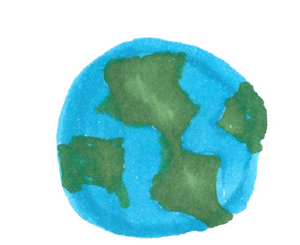Our world today:

Our world today? Maybe the G20, the ASEAN Summit, the drastically increased use of social media, my favorite e-sports team didn't pass the playoffs. The most interesting incident for me was my favorite e-sports team, EVOS Legends which usually always passed the playoffs in MLBB Professional League Indonesia (MPL ID), but in the current season, namely S10, EVOS Legends did not pass the playoffs.

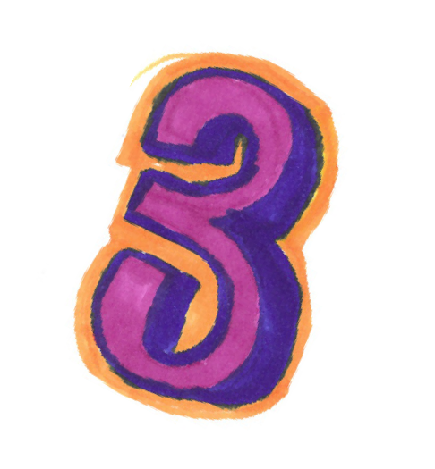3 Things to remember:

First, focus on what can be done now. Create a target that must be achieved every day until it reaches the planned goals. Remember, don't stop when you're tired, stop when you're done.

Second, there is no need to worry about other people who were successful first. Everyone has their own way of life.

Third, if there are times when you feel like a failure, low self-esteem, do not deserve something, there is no need for regret because these things are also a process to achieve the goals. Believe that beautiful things await the end.

My hope for the future:

What will the world be like in the next six years? I think the role of IT has become mandatory for people in carrying out their daily lives or it is possible that there are robots that can act like humans. There will be new trends, fashion, food, and others.

In the future, I can achieve my target, which is to become a Mobile Apps Developer, and after graduating from BINUS UNIVERSITY, I want to continue my education to postgraduate abroad by applying for a global korea scholarship (GKS) while working as a Mobile Apps Developer.

...

Dear, My future self, how is your world doing? Where do you live? Did you achieve your dream job? Did you achieve your goals? Are you still in love with M?. I'm sure you can reach it. KEEP SPIRIT! HWAITING!!!

Doodle here:



(Michael Geraldin Wijaya, 15 November 2022)